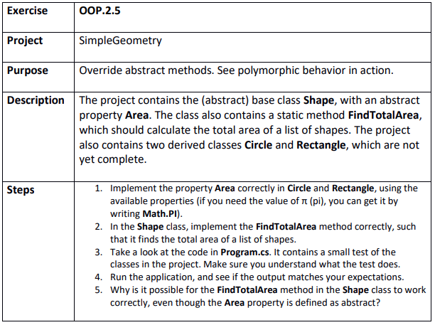

Step 1
SimpleGeometry.sln

Step 2
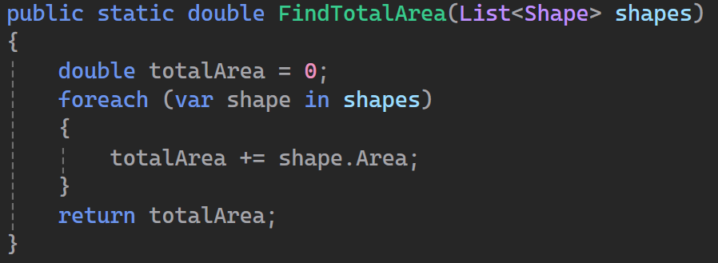

Step 3
Good

Step 4
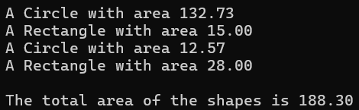

Step 5
Polymorphism. Even since the Shape class is abstract and the Area method is abstract it means that every Object of type Shape must have an implementation in their own shape subclass of the Area method. So if we know something is of type shape we also know that is has an area method implementation.

